# **Driver Attentiveness in Virtual Reality (Experimental Research Project)**

# Aim:

The aim of the project is to investigate how different scenarios can positively or negatively affect a driver’s reaction time whilst driving a car. On average 5 people die on the road per day in Great Britain, see [1], this project aims to provide research that can help to reduce that number.

* **Short-Term Goal:** Give reliable information into which technologies (current or new) aid or distract drivers.
* **Long-Term Goal:** Help to push government regulations and ultimately - reduce road deaths.

# Objectives:

* Become **skilled** and **experienced** using Unity in a 3D environment.
* **Learn** how to program for Virtual Reality hardware.
* Have a **successful experiment**, where at least 10 different people are tested & sufficient reliable data is collected.
* **Research** different literature & data for both real and simulated experiments in similar areas.
* **Learn** basic 3D modelling in Maya (as it’s industry standard).
* **Stick to a schedule** and complete tasks on time.

# Literature Review:

### Road Accidents/Fatalities:

On average, in Great Britain, 5 people die per day on the road and many more are injured [1]. There are many different determining factors in these accidents that need to be explored, what are the main causes of road accidents and what percentage of those is the driver at fault? See [2], where speeding and distractions (both areas that can be easily explored in this project) make up nearly 50% of the causes of fatalities on the road. This is the area that needs to be focused on, because the aim of the project is to provide more data into what could potentially cause a driver to have an accident and data into what technology could potentially prevent a driver from causing an accident.

A list of the various reported causes of road traffic accidents [3] lists “driver failed to look properly” as the number 1 reported cause, which is not something that can be easily fixed with software/hardware (apart from self-driving vehicles). However, number 2 is “driver failed to judge the other persons path or speed” which is something that can be very easily tested within this project, and there is high potential for hardware feasibly being able to fix this problem. For example: in the project I could simulate two different scenes – one where there is no indicator of the car in front slowing down, and another where there is an audio (beep) and visual (red light) stimulus for when the car in front is slowing down significantly – then check how quickly the test subject reacted to the car in front slowing down for both scenarios. If there is a significant improvement with reaction times and braking times with the audio and visual stimulus then there is good evidence to suggest that if a company created that technology it would reduce road traffic accidents, as that is the number 2 reported cause.

In regards to other variables to look out for, see [4] where fatigue is focused as a large potential source of accidents in general (including driving accidents). It notes that variables that could be the key cause of fatigue: age, sex, race, socio-economic status, and marital status – are mainly used as descriptive terms (independent of the study) rather than confounding ones. They recommend to record this demographic data of subjects and include these variables within the datasets to help with future research. Further data [5] suggests that you are three more times likely to be in a car crash if you are fatigued and that driver reaction times, awareness of hazards, and general attentiveness is worsened by driver fatigue.

A previous driving virtual reality simulation study was done [6] on subjective risks of driving behaviour – it found that the risk perception of the driver in a specific driving scenario is a key factor in whether they will crash or not. Independent of driver skill, those who crashed were more confident in their success of correctly performing a difficult manoeuvre, hence chose to try and drive through tighter gaps, than those who did not crash.

### Virtual Reality:

Some users report to have motion sickness (nausea), loss of spatial awareness, and/or dizziness while using Virtual Reality devices. To quote [8] “The makers of the most popular VR headsets, the Oculus Rift and HTC Vive, recommend taking at least a 10 to 15-minute break every 30 minutes, even if you don’t think you need it”. Hence, I should be tracking the time that each participant takes and make sure that I design the experimental simulations to last less than 30 minutes per person (For example: Three 5-minute simulations, with a minute in between) in order to lower the risk of a subject getting sick due to my experiment.

A project [7] on a motion sickness measurement index in a virtual reality environment developed a Virtual Reality Sickness Questionnaire (VRSQ), a variant on a Simulation Sickness Questionnaire (SSQ), which could be used in testing to check whether my application consistently makes users feel ill or not (as that could definitely become an unwanted factor on the results). Also see [9] where the study suggests women in particular are affected by motion sickness in the oculus rift more than men are – another factor to take into account. [11] lists the potential causes of motion sickness within virtual reality experiences, and suggests potential solutions including: ambisonic sound to match the sense of movement, letting users rest between scenes, adding rest frames (fixation points) for users to be able to focus on, reducing virtual rotations, and reducing angular velocity. The majority of these concepts can be applied to my project and should be considered when designing the application.

Another factor that could affect the results of the project is whether a dangerous situation (potential car crash) is treated as a serious situation within a virtual reality environment. A study on psychological responses to an emergency in virtual reality [10] suggests “a virtual emergency can be staged in a virtual environment since users would acknowledge it as such” from their results, which adds credibility to any potential results I get from my experiment. The study also goes into racial discrimination in a virtual reality situation but that is not relevant to my project.

### Potential Distractions:

There are several possible distractions that can occur when driving a car, see [12] where many are listed. However, the focus of this study is on things that can be controlled or changed (by regulation or new technology) hence distractions such as “Spotting an attractive driver at traffic lights” or “Seeing a classic motor on the road” are not something that are not reasonably possible to change. There will never be a ban on attractive drivers or interesting cars, hence I am focusing on things within the car (that the driver can control).

A good example of a distraction that fits this mold would be using/following satnavs whilst driving, as this is not illegal (as long as the satnav is mounted and not on a mobile phone [13]) but is definitely has a high probability of distracting a driver. Another good example would be filming using a mobile phone, or using a handsfree phone, as again both are currently legal in the UK [13] and fit the mold perfectly.

To add a final example, loud music (above 95 decibels) has been shown to lower reaction times of drivers [14] “Newfoundland’s Memorial University found that reaction time can slow as much as 20% when someone is listening to loud music” - which increases the likelihood of a crash occurring. This is the case even more with teen drivers “93% of novice drivers play loud music when they’re behind the wheel”, and more likely when drivers are listening to their favourite music “Of the 85 subjects, 98% made errors when listening to their own music”.

The University of Utah did a study on the current technology in cars (in 2017) and found that a lot of the technology in cars are distracting to the driver [15]. To quote the study [15] “In the new study, programming navigation was the most distracting task -- taking drivers on average 40 seconds to complete. Text messaging was the second most distracting task; audio entertainment and calling and dialing were the easiest to perform and did not significantly differ in overall demand”.

### Potential Driving Aids:

As well as researching and investigating driving distractions, I want to look at any potential methods that could help the drivers react more quickly and be more attentive at the wheel – although unlikely that I will be able to come up with or create any new techniques. There are a few up and coming technologies that would provide a dramatic help for such as Automated Braking [17] which would remove human error and slower human reaction times in emergency situations, Brain to Vehicle Technology [16] to improve reaction times as the technology will be able to react to a situation in the correct way much faster than the user, as well as Self-Driving Car Technology [18] which would completely remove human error for every situation in a car (as well as emergency situations) but is only achievable in certain situations at the moment (not full-blown automation, where no human input is needed). However, these are long term goals and will take a while to be perfected or to be affordable to everyone on the road. So, in the meantime most drivers will be stuck with their own reactions, skill, and wit when driving a car for the foreseeable future. Therefore, I believe it would be beneficial for more basic technology to be developed to bridge the gap between cars now and future (more useful) technology and reduce road traffic accidents/deaths in that time gap.

If we look at possible technology for improving reaction times, a key area could be using auditory stimulus instead of visual stimulus. I took a test for reaction time to a visual cue [19] and got a (233.20ms average), whereas my reaction time to an auditory cue [20] was significantly faster (170.57ms average). Studies, see [21], have shown this to likely be true “The reaction times for the visual stimuli are appreciably slower than the auditory reaction times”. Although they’ve noted that “visual and auditory reaction times are nearly the same if the visual stimulus is photopic and the apparent magnitude of the stimuli are nearly the same” however it is difficult to compare magnitudes of visual and auditory stimuli.

Another positive factor for having an auditory stimulus (that alerts the driver) is that the computational time for figuring out if a situation is dangerous (car suddenly brakes in front of you) has been done by a computer and not a human. Hence, the human should realise they are in a dangerous situation faster than they would have with just visual stimuli, which would (in theory) further improve the reaction time. The trouble with this idea is creating a technology that is accurate and reliable enough for the user to trust it, so that the user reacts before they have comprehended the situation, rather than waiting to weigh up the situation themselves and then react (which is what I imagine most people would do). Another problem is that a simple alert sound cannot communicate the complex situation to the user, so it would have to be reserved for one situation only (For example: emergency stops) which doesn’t allow the user to react to other situations more quickly (For example: swerving out of the way of a pedestrian).

This technology is very possible using object detection/recognition [22], but very hard not to have errors at some point (especially taking into account different road laws in countries, and countless situations that could or could not be considered dangerous) and an alert going off when there isn’t a dangerous situation (and vice versa) could cause an accident rather than preventing one. Overall, even if users do not instinctively react to the alert, it would at least cause a distracted user (asleep or on their phone, etc.) to have knowledge that there is a situation they might need to react to, so it may be worth testing as a variable to see if it would help first then the technology can possibly be perfected later - however by that point the other long term solutions I listed [16] [17] [18] would likely be more cost effective and better at dealing with the issue. Therefore, I will be focusing on distractions whilst driving, instead of driving aids.

# Design:



# Milestones:

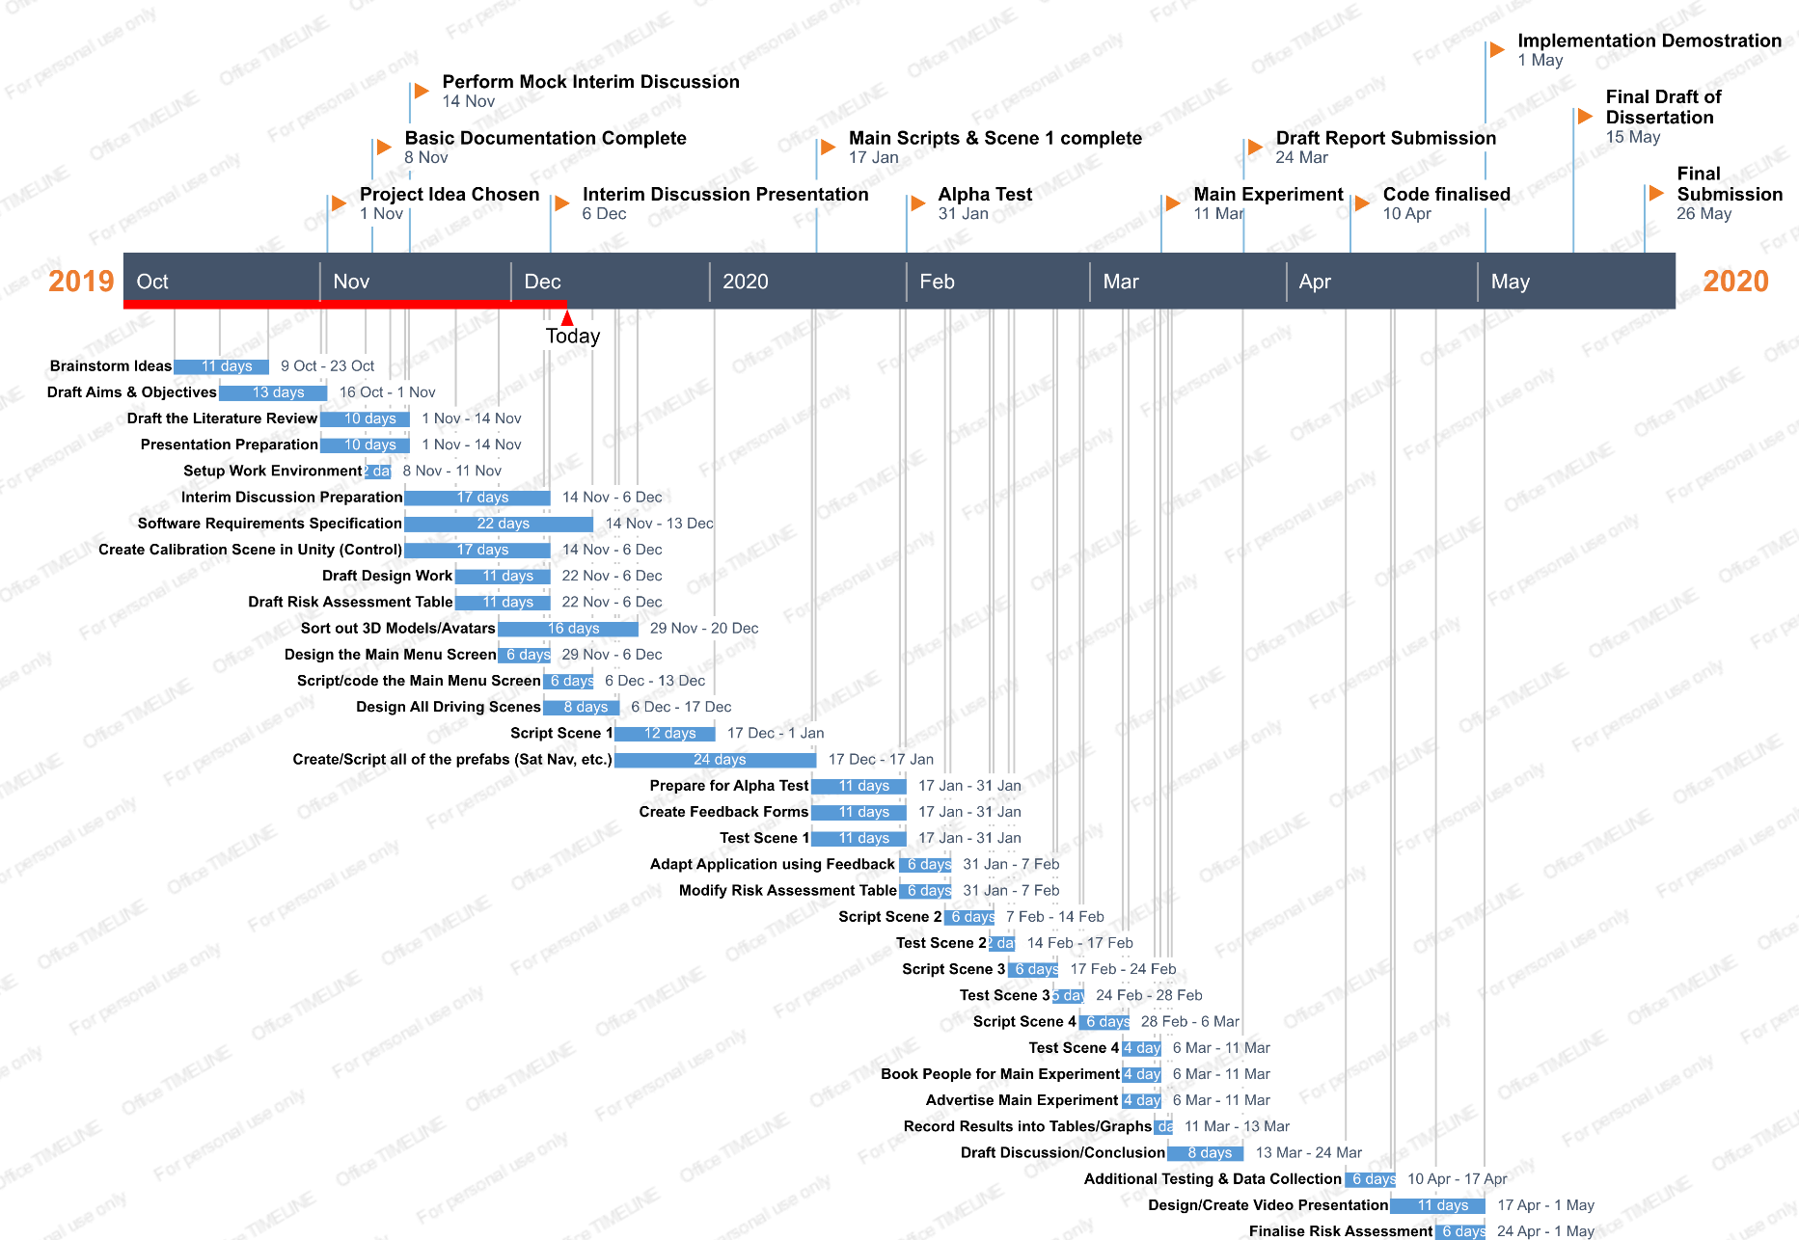

# References:

[1] <https://www.brake.org.uk/facts-resources/1653-uk-road-casualties> - Brake UK 2017 report on road casualties.

[2] <https://www.aceable.com/safe-driving/car-accident-statistics/> - Aceable US driving fatality data (2007 – 2012).

[3] <https://www.regtransfers.co.uk/content/common-causes-for-road-accidents-in-britain/> - latest statistic from the department of transport (in Britain) for the most common causes of road traffic accidents (published 2nd July 2018).

[4] <https://www.sciencedirect.com/science/article/pii/S0001457509003327> - Accident Analysis & Prevention (Volume 43, Issue 2, March 2011, Pages 516-532)

[5] <https://www.nsc.org/road-safety/safety-topics/fatigued-driving#:~:targetText=A%20study%20by%20the%20AAA,times%20the%20police%2Dreported%20number.&targetText=NHTSA%20estimates%20fatigue%2Drelated%20crashes,annually%2C%20not%20including%20property%20damage.> – National Safety Council article on “drowsy driving” (2019)

[6] <https://www.sciencedirect.com/science/article/pii/S0001457513003497?via%3Dihub> - Accident Analysis & Prevention (Volume 62, January 2014, Pages 63-78)

[7] <https://www.sciencedirect.com/science/article/pii/S000368701730282X> - Applied Ergonomics (Volume 69, May 2018, Pages 66-73)

[8] <https://www.businessinsider.com/virtual-reality-vr-side-effects-2018-3?r=US&IR=T#loss-of-spatial-awareness-1> – Business Insider “Here's what happens to your body when you've been in virtual reality for too long” by Kaylee Fagan (Mar 4, 2018, 4:00 PM)

[9] <https://search.proquest.com/docview/1877838144?accountid=17256&rfr_id=info%3Axri%2Fsid%3Aprimo> - Experimental Brain Research (Volume 235, Issue 3, Pages 889-901)

[10] <https://www.sciencedirect.com/science/article/pii/S0747563215000540?via%3Dihub> - Computers in Human Behavior (Volume 48, July 2015, Pages 104-113)

[11] <https://uxplanet.org/motion-sickness-in-vr-3fa8a78216e2> - Motion Sickness in VR by Anastasiia Ku (Nov 29, 2018)

[12] <https://www.mirror.co.uk/news/uk-news/50-worst-driving-distractions-been-11319752#:~:targetText=Heavy%20rain%2C%20backseat%20drivers%20and,their%20eyes%20off%20the%20road.> – 50 Worst Driving Distractions (Article by the Mirror)

[13] <https://inews.co.uk/inews-lifestyle/cars/mobile-phone-driving-law-changes-explained-uk-new-legislation-824749#:~:targetText=At%20the%20moment,%20using%20a,nav%20while%20driving%20is%20illegal.&targetText=You're%20able%20to%20use,in%20these%20cases%20is%20illegal.> – UK Mobile Phone Laws Whilst Driving

[14] <https://www.idrivesafely.com/defensive-driving/trending/7-deadly-sins-distracted-driving-wrath-music> - Music Whilst Driving Affecting Reaction Times (Newfoundland’s Memorial University study & Ben-Gurion University in Israel study)

[15] <https://www.sciencedaily.com/releases/2017/10/171005102710.htm> - University of Utah Study on common driving technologies that should not be used whilst driving (2017)

[16] <https://roadsafetygb.org.uk/news/brain-to-vehicle-technology-will-speed-up-reaction-times-nissan/> - Nissan Brain to Vehicle Technology (Article by RoadSafetyGB)

[17] <https://mycardoeswhat.org/safety-features/automatic-braking/> - Automatic Braking explained (Article by MyCarDoesWhat.org)

[18] <https://www.fool.com/investing/2017/10/22/how-far-along-is-self-driving-car-technology-reall.aspx> - Self-Driving Cars Progress (Article by John Rosevear, Oct 22, 2017 at 7:05AM)

[19] <http://cognitivefun.net/test/1> - Visual Reaction Test

[20] <http://cognitivefun.net/test/16> - Auditory Reaction Test

[21] <https://www.sciencedirect.com/science/article/pii/000169188490043X> - Visual and auditory choice reaction times (Acta Psychologica: Volume 55, Issue 3, May 1984, Pages 231-247)

[22] <https://towardsdatascience.com/evolution-of-object-detection-and-localization-algorithms-e241021d8bad> - Evolution of Object Detection and Localization Algorithms (Article by Prince Grover, Research Scientist at Amazon Web Services)